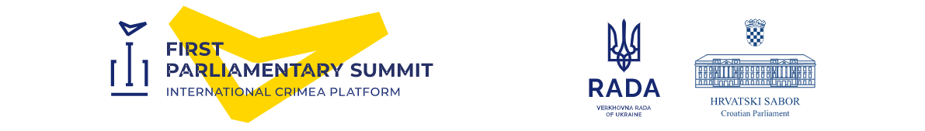
First Parliamentary Summit of the International Crimea Platform
Zagreb, 24-25 October 2022
MEDIA ACCREDITATION FORM
Please fill in one form for each participant and return until 20 October 2022 to: press.crimea.zagreb@sabor.hr

Title | ☐Mr. ☐Ms.
First name | Enter name
Last name | Enter last name
Date of birth | Enter date of birth dd.mmm.yyyy
Country of birth | Enter country
Citizenship | Enter citizenship
E-mail | Enter email
Mobile phone number | Enter number
ID Document type (ID card, passport) | Enter document type
ID Document number | Enter document number
ID Document Date of Expiry | Enter date of expiry dd.mm.yyyy
ID Document Issued by | Enter title of institution
Media | Enter media/company name
Editor-in-Chief | Enter name and surname
E-mail of editor-in-chief | Enter email
Media equipment (TV/photo cameras, tripods, laptop, etc.) | Enter info

Please upload:
Copy of ID document, front page with photo (format jpg, jpeg, 3 Mpix minimum, 3MB maximum)
Personal photo (passport format 3.5 cm x 4.5 cm for accreditation badge (jpg, jpeg, min. 3 Mpix – max. 3MB)

Note:
Before sending to press.crimea.zagreb@sabor.hr, please save this form the following way:
„CrimeaAccreditation_Media name_Surname Name“
(example: CrimeaAccreditation_Croatian Television_Nickolson Jack)

IMPORTANT: Please read the Data Protection Notice

